**Tailwind CSS notes**

**What is Tailwind CSS?**

**Tailwind CSS** is a utility-first CSS framework.  
It helps you style your website directly in the HTML using predefined classes.

Instead of writing custom CSS, you use **ready-made classes** like:

html

<p class="text-red-500 font-bold text-xl">Hello Tailwind!</p>

| **Feature** | **Description** |
| --- | --- |
| 🎨 Utility-first | Style directly with classes, no need to write custom CSS. |
| ⚡ Fast Prototyping | Quickly create UI without switching files. |
| 🧩 Customizable | You can configure your own theme, colors, spacing, etc. |
| 🛠️ Responsive Design | Built-in responsive breakpoints. |

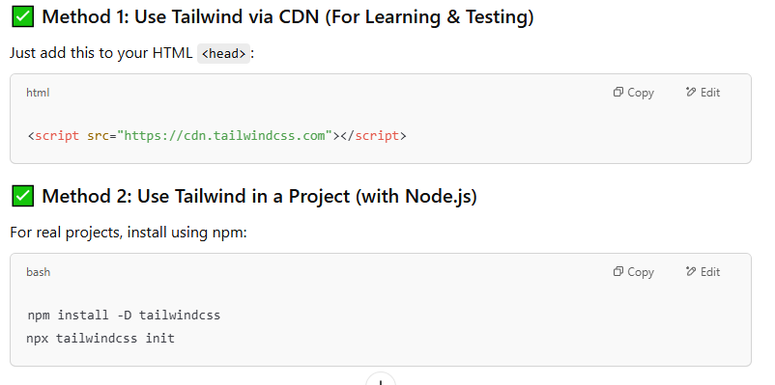

**Basic Tailwind Concepts**

**1. Text & Font Classes**

| **Class** | **Example** | **Description** |
| --- | --- | --- |
| text-lg | Large text | Sets font size |
| font-bold | Bold text | Sets font weight |
| text-red-500 | Red color | Sets text color |

<p class="text-xl font-semibold text-blue-600">Hello, World!</p>

**2. Spacing (Margin & Padding**

| **Class** | **Description** |
| --- | --- |
| m-4 | Margin all sides |
| mt-2 | Margin top |
| p-4 | Padding all sides |
| px-2 | Padding left & right |

<div class="mt-4 p-6">I have margin and padding!</div>

**3. Layout (Flexbox & Grid)**

<div class="flex justify-between">

<div>Item 1</div>

<div>Item 2</div>

</div>

**Grid Example:**

**<div class="grid grid-cols-2 gap-4">**

**<div>Box 1</div>**

**<div>Box 2</div>**

**</div>**

**4. Backgrounds & Borders**

**<div class="bg-yellow-200 border border-black p-4 rounded-lg">**

**Stylish box!**

**</div>**

**5. Buttons Example**

<button class="bg-blue-500 hover:bg-blue-700 text-white font-bold py-2 px-4 rounded">

Click Me!

</button>

**6. Responsive Design**

Use breakpoints like:

* sm: for small (≥640px)
* md: for medium (≥768px)
* lg: for large (≥1024px)

<p class="text-sm md:text-lg lg:text-xl">Responsive text</p>

## **Simple Project Example**

<!DOCTYPE html>

<html lang="en">

<head>

<meta charset="UTF-8" />

<meta name="viewport" content="width=device-width, initial-scale=1.0" />

<title>Tailwind Demo</title>

<script src="https://cdn.tailwindcss.com"></script>

</head>

<body class="bg-gray-100 text-center p-10">

<h1 class="text-3xl font-bold text-purple-600 mb-4">Welcome to Tailwind CSS!</h1>

<p class="text-lg text-gray-700">Build beautiful websites with simple classes.</p>

<button class="mt-6 bg-green-500 hover:bg-green-700 text-white font-bold py-2 px-4 rounded">

Get Started

</button>

</body>

</html>

## Summary

| **Concept** | **Class Example** |
| --- | --- |
| Text Size | text-xl |
| Color | text-red-500, bg-blue-300 |
| Spacing | m-4, p-2 |
| Layout | flex, grid, justify-center |
| Borders | border, rounded-lg |
| Hover Effects | hover:bg-red-500 |